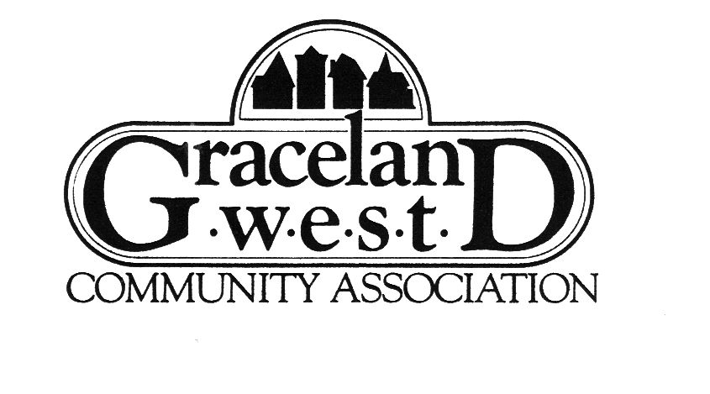
Membership Form

Type of Membership: $10 Individual (one year) $15 Family (one year)
(circle one) $35 Individual (five years) $50 Family (five years)

Name___________________________________

Address_________________________________

Home Ph: ________________________________

Work Ph: _________________________________

Cell Ph: __________________________________

E-mail address

Name___________________________________

Address_________________________________

Home Ph: ________________________________

Work Ph: _________________________________

Cell Ph: __________________________________

E-mail address

Chicago police tell us the best way to protect against criminal activity is to know and care about your neighbors. So GWCA would like to publish the names and phone numbers of our paid members and mail it to other paid members. Please circle any info above that you do NOT want us to publish in this directory.

Signature _______________________________________________________ Date __________________________

I am interested in leaning more about volunteer opportunities for GWCA (check any that interest you):

- serve on advisory council (18 month term)
- Help plan/organize events/parties
- Help for two hours during GWCA fest (9/6)
- Help for two hours at Halloween party (10/26)
- Help design the GWCA website
- Write for the newsletter
- Represent my block as a Block Rep
- Help set up or clean up events/parties
- Deliver the newsletter on my block
- Solicit advertising
- Solicit Donations
- Unique Skill or interest:

_______________________________________

_______________________________________

_______________________________________

Make checks payable to: GWCA

Send or drop off CHECK & COMPLETED FORM to:
Kathy Scardina, 4325 North Greenview Avenue, Chicago, IL 60613

Additional comments to or requests for GWCA (continue on back if necessary):

